**NEURAL NETWORKS & DEEP LEARNING**

**ASSIGNMENT – 5**

NAME : SRAVANI MANNURU

STUDENT ID : 700766162

GITHUB LINK : https://github.com/sravs2031/Neural-Networks-ICP5.git

VIDEO LINK : https://drive.google.com/file/d/1iNo-Gu6vSCgZDB8xNvPIrV6gVni_kVD4/view?usp=drive_link

SCREENSHOTS :

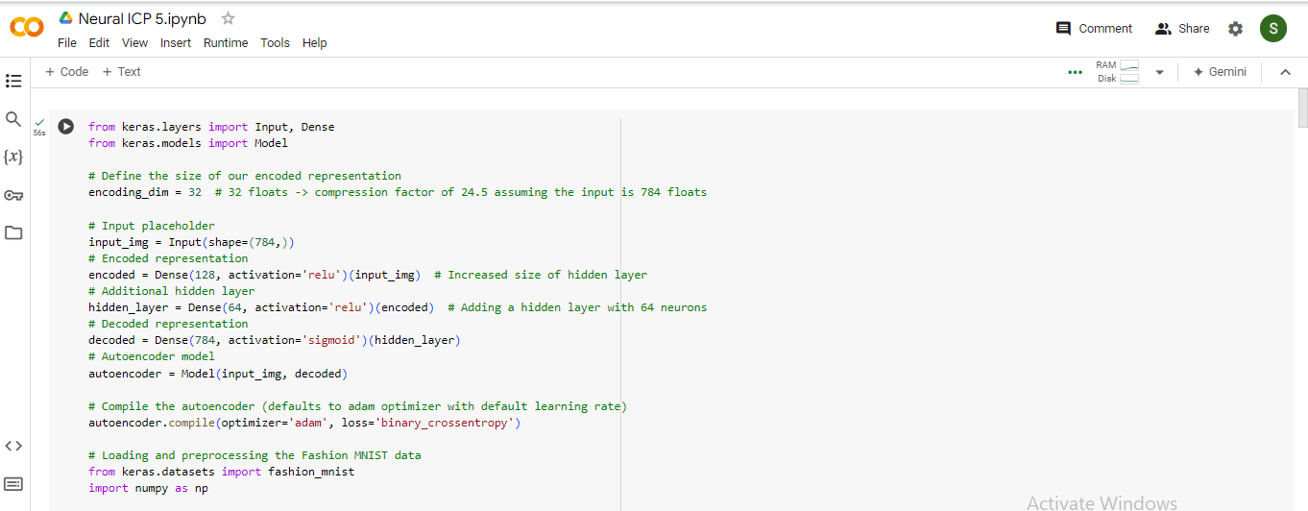

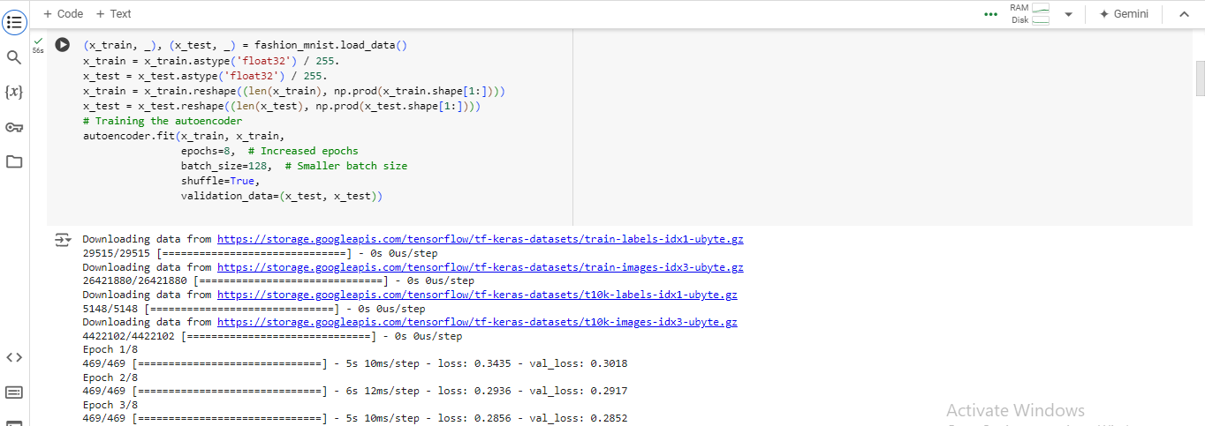

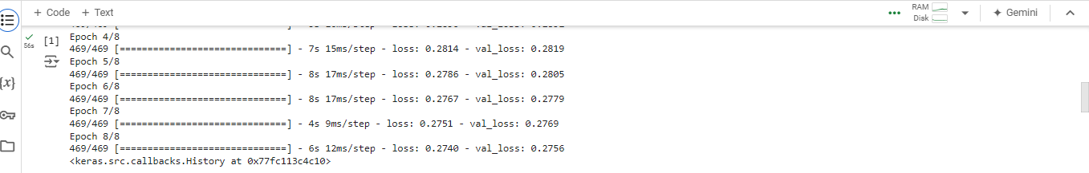

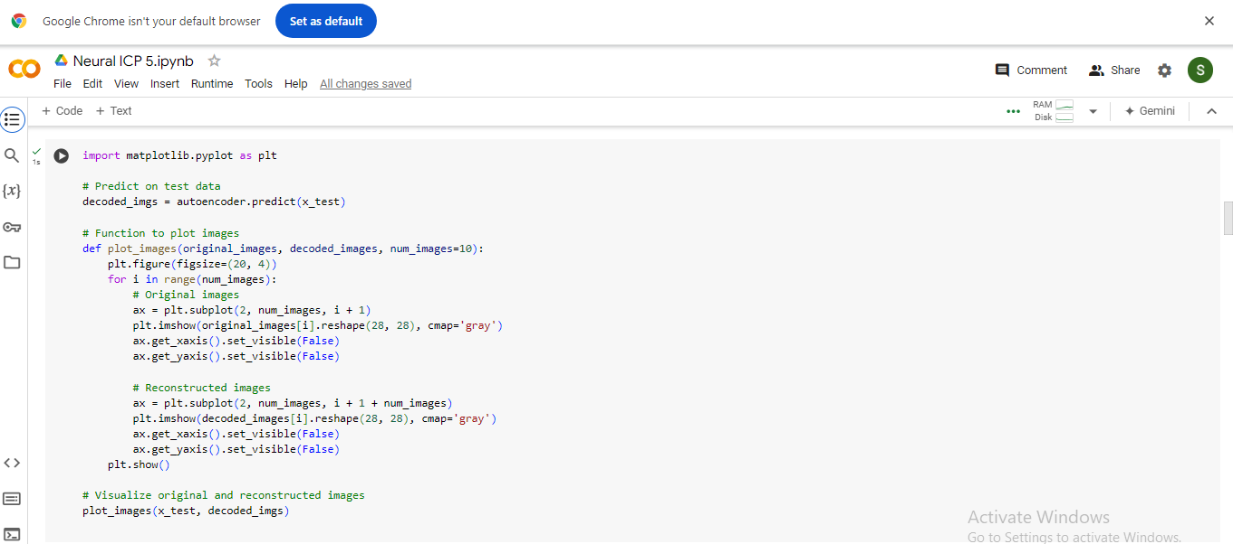

OUTPUT:

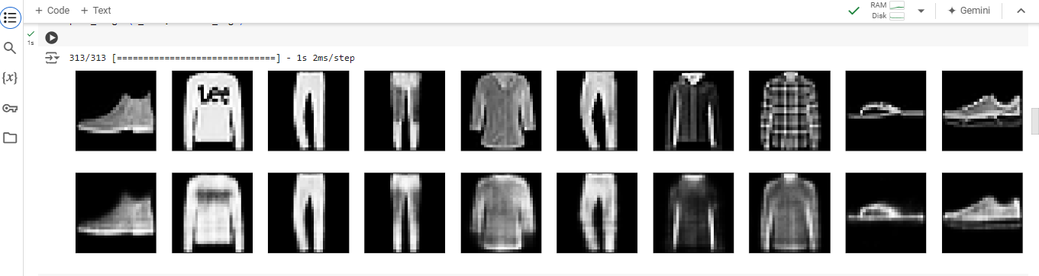

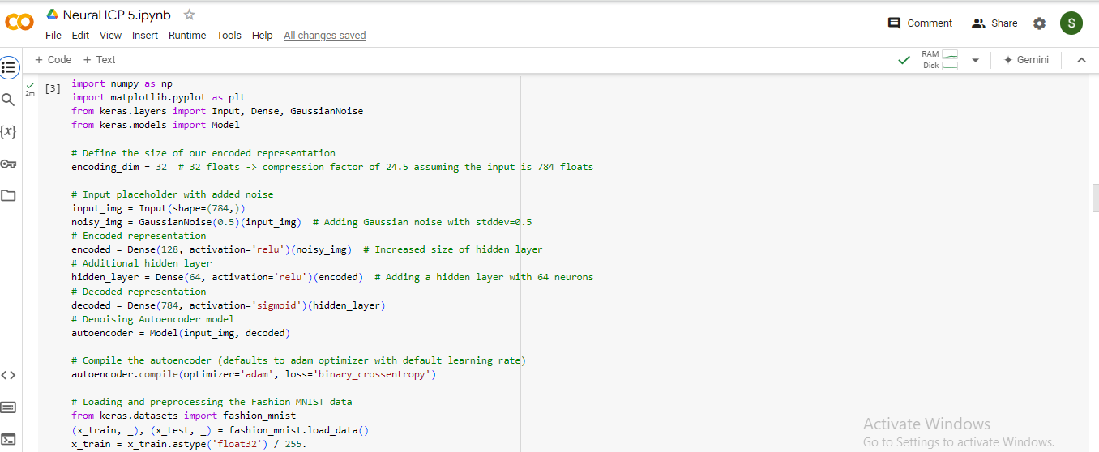

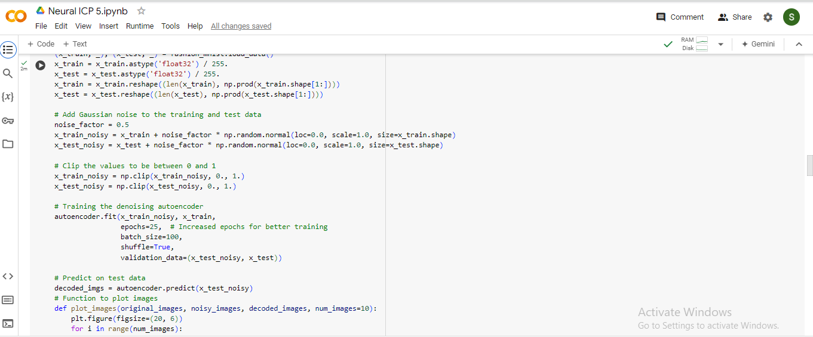

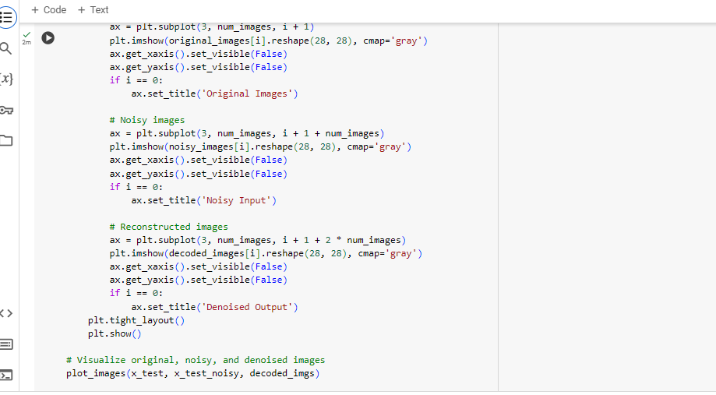

OUTPUT:

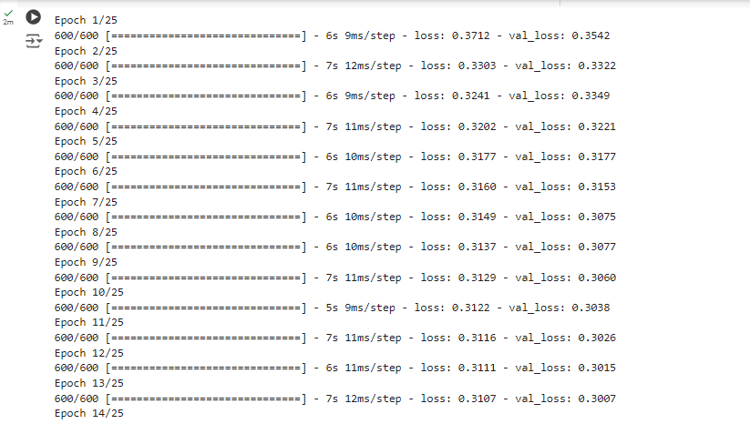

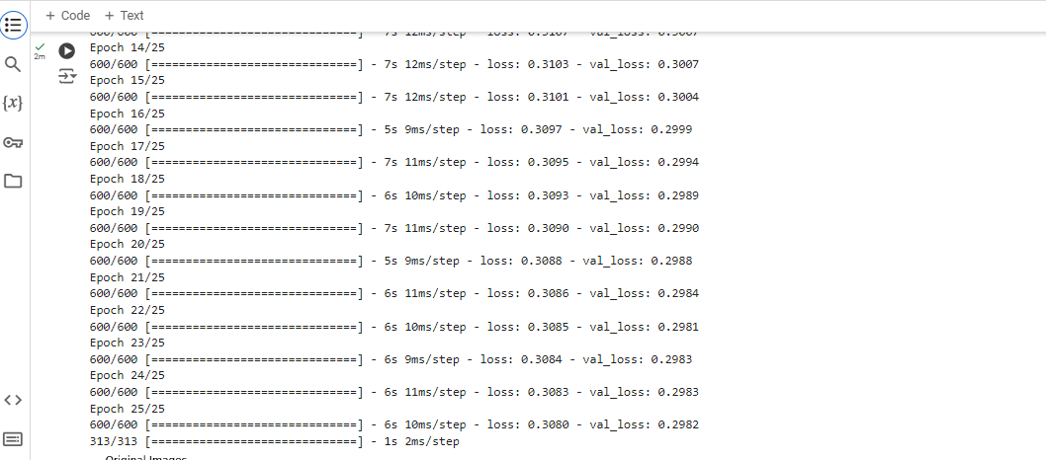

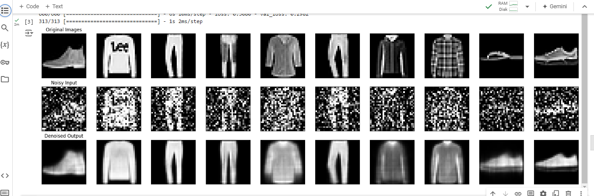

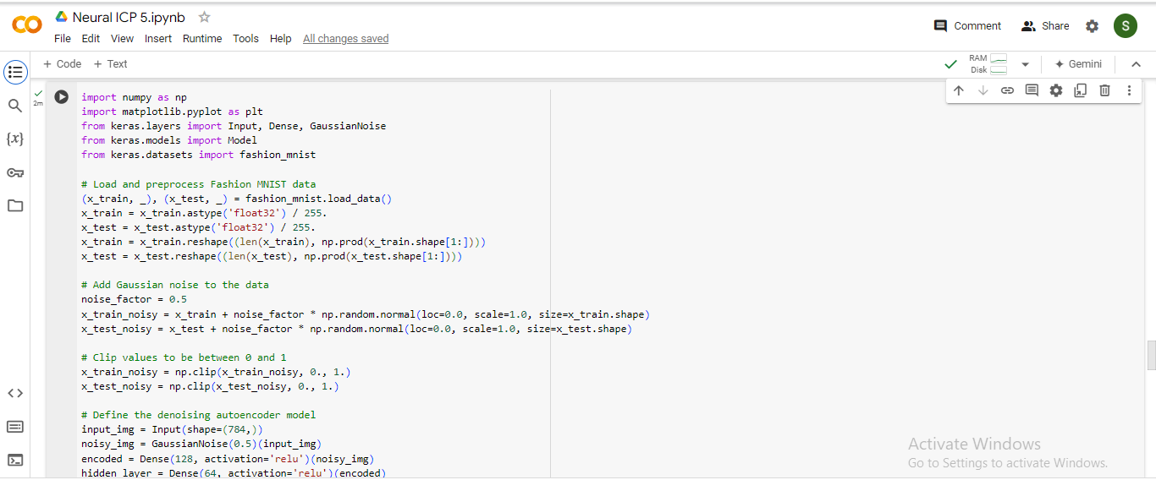

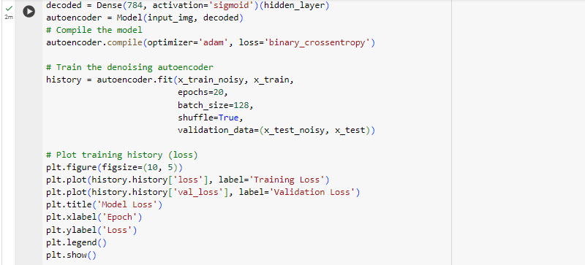

OUTPUT:

